**Team Members**

***STRs_Expo:***

*R.T.Rishi Varman-CSE*

*S.V.Shailesh Babu-CSE*

*A.Yudhish Kumar-CSE*

**PRODUCT LIFECYCLE FORECASTING**

**Problem Statement:**

Predicting part life cycle of cars by utilizing machine learning. The life cycle of parts has been dramatically decreasing over the past three decades, creating a vast increase in need for accurate part life cycle predictions. This is necessary as it is important to either find similar parts to replace the obsolete ones or to find new manufacturers for those parts.

**INTRODUCTION:**

The European Commission forecasts a 50% increase in transportation over the next 20 years. This will lead to a capacity crunch as the infrastructure development will not match the increase in traffic. It will require high efficient transportation solutions to maintain the transport performance of today. Together with the demand for sustainable transport solutions, more complex transport systems will evolve. This system should be able to detect the wear of parts and units of cars based on the usage data and their types. The basic method for determining the vehicle state is to use the mathematical model of wear , which allows calculating the remaining useful lifetime of the car based on measured data.

**PROPOSED SOLUTION:**

Our aim is to create a machine learning model and fit it in a website by creating it, which can be used by both an individual or a company to predict a life time of any car. The proposed solution for determining the technical state of car and its remaining useful lifetime is based on the comparison of current vehicle state with expected state. The current state of vehicle is determined by processing the information from the given dataset while the expected state is determined using the mathematical model of wear for the given characteristics of a car(eg: Fuel type, mileage, kilometres driven) .The comparison of vehicle current state and expected state allows determining operation conditions and forecasting the remaining useful lifetime of car on this basis.



**METHODOLOGY:**

I got the dataset which includes the used cars list in India along with its various features and information from [www.kaggle.com/datasets](http://www.kaggle.com/datasets).

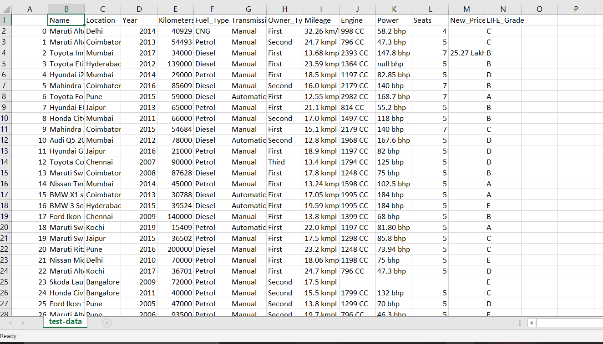

This dataset provides us the information of many cars features like:

1.year of the vehicle

2.fuel type

3.Transmission

4.ownership

5.mileage

6.power

7.kilometres driven

8.Vehicle grade

**PARAMETERS**

There are many parameters/variables provided in the dataset. The parameters/variables are divided into two types.

They are

1.Dependent variable

2.Independent variable

The **independent variables** are:

1.Year of the vehicle

2.Fuel type of vehicle

3.Mileage of the vehicle

4.Kilometres driven using the vehicle

5.The ownership of the vehicle

6.The transmission of the vehicle

The **Dependent variable** is **Vehicle grade**

|  |  |
| --- | --- |
| **Vehicle grade** | **LIFE-TIME** |
| A | 17-20 years |
| B | 13-16 years |
| C | 10-12 years |
| D | 7-9 years |
| E | 4-6 years |

This table says us what the particular life grade means .Using the independent variables we will design a model to predict the dependent variable

**TECHNIQUES USED:**

As far as now we have planned to use **Multiple regression** for predicting the model of the life grade.

This is the general equation for the multiple linear regression

​*yi*​=*β*0​+*β*1​*xi*1​+*β*2​*xi*2​+...+*βp*​*xip*​+*ϵ*

**where, for***i*=*n***observations:**

*yi*​=dependent variable

*xi*​=indipendent variables

*β*0​=y-intercept (constant term)

*βp*=slope coefficients for each explanatory variable

*ϵ*=the model’s error term (also known as the residuals)​

1.There are many independent variables in the dataset.

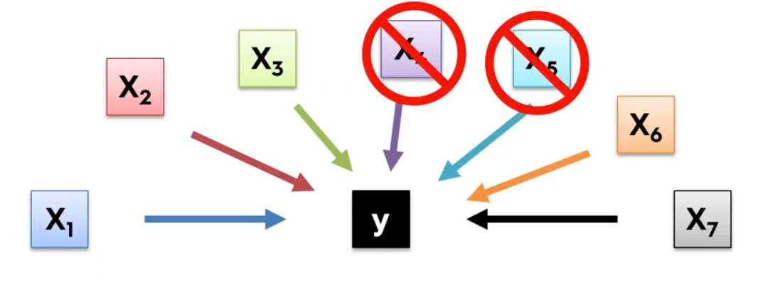

2.A Significance level(SL) is set.

3.p value is found for every independent variables.

4.If p value>SL then the particular dependent variable is removed

5.The step four is repeated for all independent variables of the dataset.

6.Finally the best model is fit

**AFTER FITTING THE MODEL:**

After the model is fitted the graph of the model is scrapped out to check how for our predicted model is correct with the scattered points of the independent variables.

The graph will be like this(its taken from google)

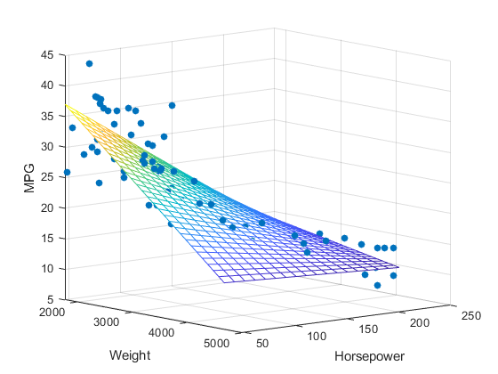

**RESULT:**

Using this model we can easily predict the Life grade of the car.

(If the model doesn’t fit properly then we will use other techniques like clustering or random forest regression)

**TECH STACK USED:**

TOOL USED:

For creating the model:

1.ANACONDA PYTHON:

2.SPYDER

For presenting it:

1.HTML

2.CSS

Libraries used In the model:

1.NumPy - adding support for large, multi-dimensional arrays and matrices, along with a large collection of high-level mathematical functions to operate on these arrays

2. Matplotlib - It provides an object-oriented API for embedding plots into applications using general-purpose GUI toolkits like Tkinter, wxPython, Qt, or GTK+. There is also a procedural "pylab" interface based on a state machine (like OpenGL), designed to closely resemble that of MATLAB

3.Pandas- pandas is a software library written for the Python programming language for data manipulation and analysis. In particular, it offers data structures and operations for manipulating numerical tables and time series.

4.sklearn- It is a free software machine learning library for the Python programming language. It features various classification, regression and clustering algorithms including support vector machines, random forests, gradient boosting, k-means and DBSCAN, and is designed to interoperate with the Python numerical and scientific libraries NumPy and SciPy.

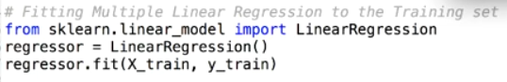

Particularly for multiple linear regression

**Business impact:**

Model simulation results show that the proposed approach for estimating of remaining useful lifetime of cars is well suited to prognostic the end of life or ageing failure. This approach is based on known monitoring data and calculates the lifetime using information about technical state of vehicles obtained from the dataset.

1.Proposed approach is well suited to be integrated into onboard equipment and may be applied in wide variety of automotive, aircrafts and similar industries where it should lead to reducing maintenance and repair costs because of timely scheduling for service.

2.The car companies can use this model to predict how long do the car they found exists by giving the independent variables of their car to the model.

3.If an individual is buying an used car he can check how long it runs by simply giving the given features of the used car.

4.Not only cars ,this technique an be used for predicting the lifetime of any vehicle.

5.This will create a very good business impact on vehicle companies as they can predict the lifetime of any new vehicle they are launching in the market by simply providing the parameters/independent variables(characteristics) of the new vehicle. This helps them to manufacture standard vehicles which lasts for long periods. This will increase their brand name as well as their profit.

***THANK YOU…!***